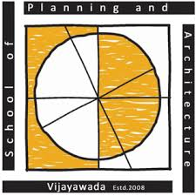
SPAV–International Journal of Planning and Architectural Science
A Journal published by School of Planning and Architecture, Vijayawada

Date:

To,
The Editor,
SPAV-International Journal of Planning and Architectural Science (SPAV-IJPAS)
School of Planning and Architecture Vijayawada
Survey No.4/4, ITI Road, Vijayawada-520008,
Andhra Pradesh, India.

Sub: Assignment of Copyright

I/We, ______________________________________________________the copyright owner(s) of the manuscript titled _________________________________________________________ _____________________________________________________________________do hereby authorize you to publish the above mentioned manuscript in the SPAV-International Journal of Planning and Architectural Science.

I/We further state that the manuscript is my/our original contribution. It does not infringe on the rights of others and does not contain any defamatory or unlawful statements. I/We have taken permission, wherever required and acknowledged the source. The work has been submitted only to this journal and that it has not been previously published or submitted elsewhere for publication.

I/We have not assigned any kind of rights of the above said manuscript to any other person/Publications.

Name of the Corresponding Author :
Communication Address :
Email ID :
Mobile no. :

Signature(s) :

